**Introduction**

Sevak is an Iot based project developed for the purpose of providing assistance and aid to the sanitation workers forced to lead unhealthy life filled with dangerous risks due to the nature of their profession. In India , poverty becomes the main factor why people are forced into this hazardous profession. The government is unable to provide better facilities to ensure the safety of these workers who are responsible for the clean and disease free towns and cities in the country.

This project includes many features such as:

* Sensor to detect fall
* Harmful gas detection
* Heart rate sensor detection
* Temperature detection
* Obstacle detection
* Location of the worker
* Alerts when the harmful gas levels goes above threshold level
* Alerts when the pulse of the worker falls below normal BPM
* Emergency button for the drainage worker in case he gets trapped

**Prerequisites** **and Various steps involved in installation**

Arduino IDE

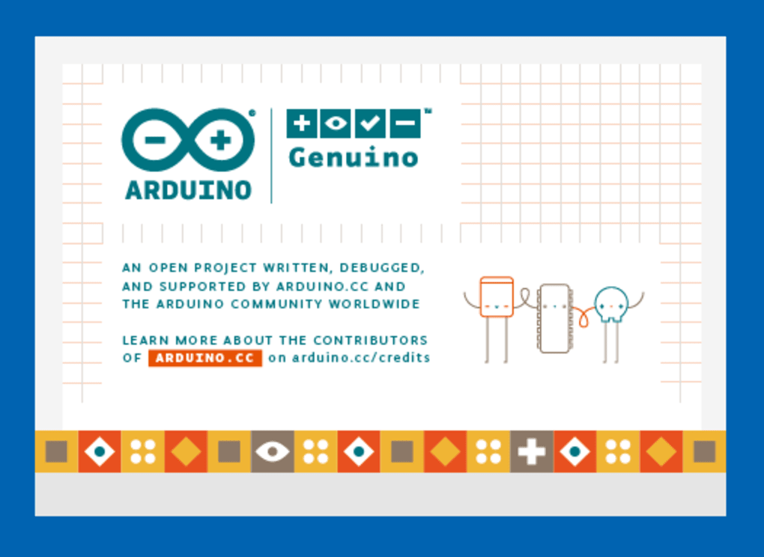

How to install Arduino IDE?

Step 1-Download the most suitable version from the Arduino official website.Unzip the file.

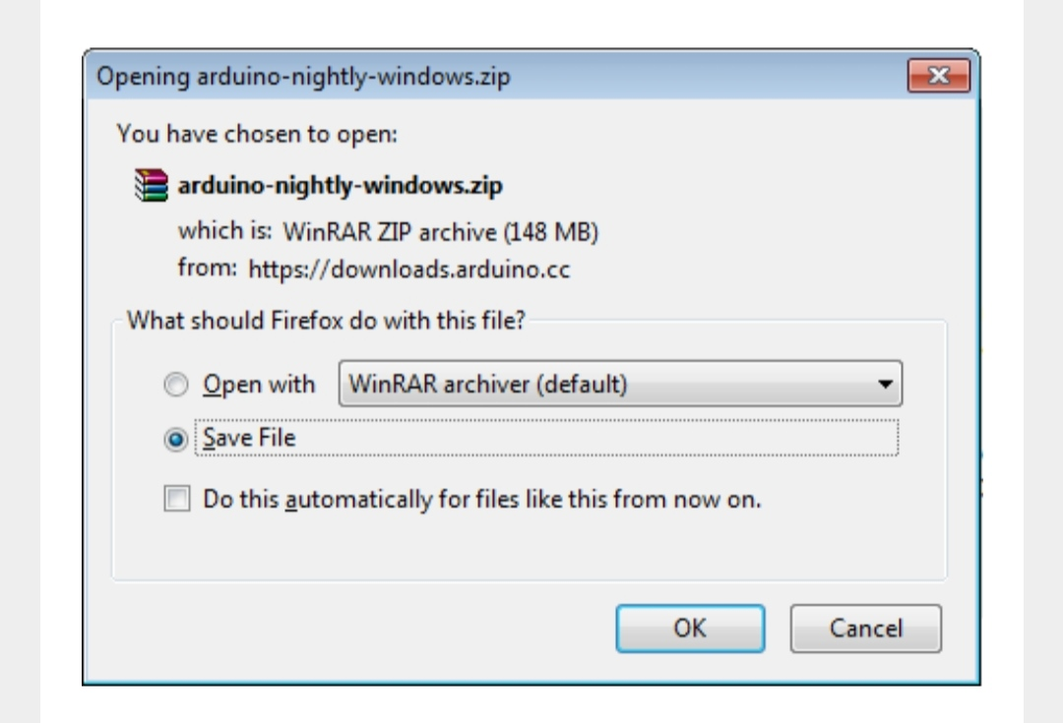

Step 2: Power up your Nodemcu.Inside the unzipped folder you can find the application icon with infinity label.Double-click to start the IDE.

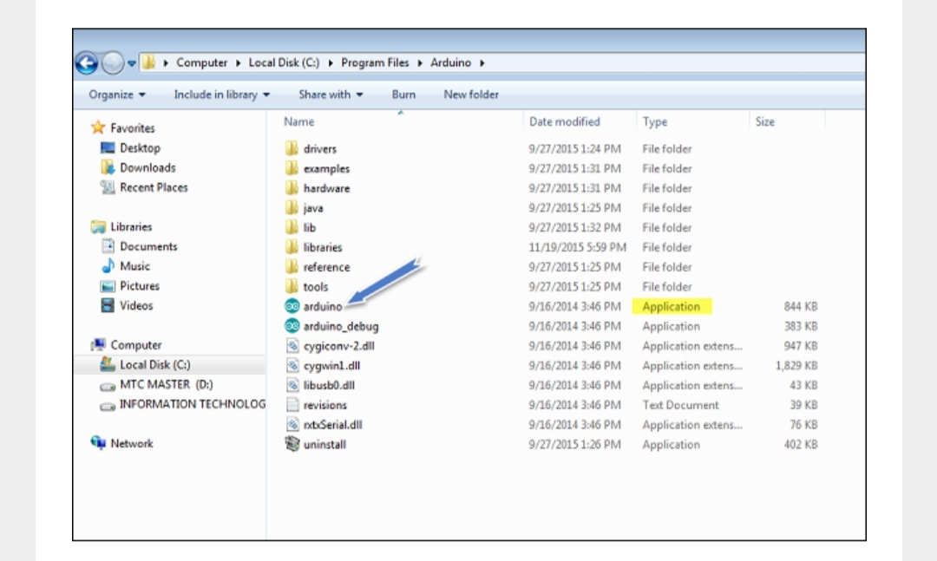

ARDUINO 1.8.12 is installed.

**Library for NodeMCU**

Link:<https://github.com/esp8266/Arduino>

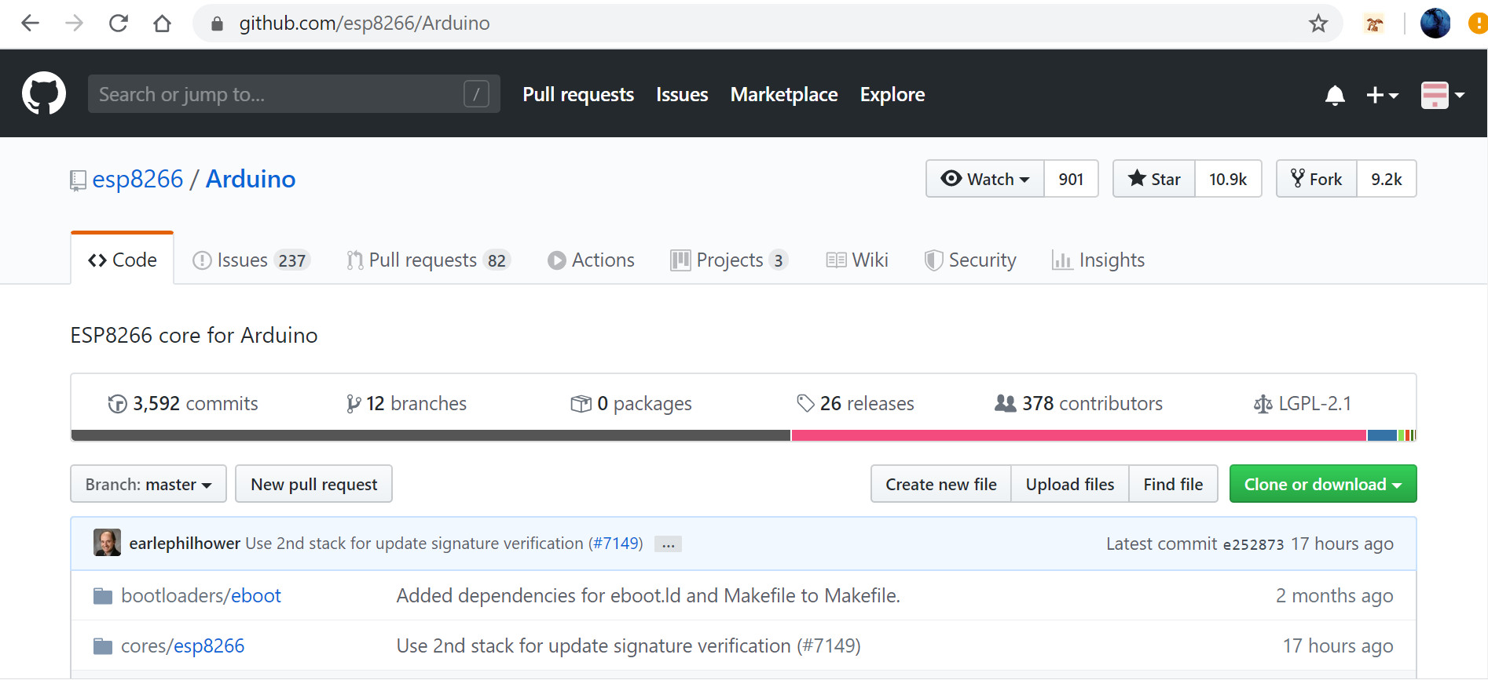

Library for NodeMCU is installed from the given link as shown above . This Library has to be used for implementing the features of the ystem using NodeMCU.

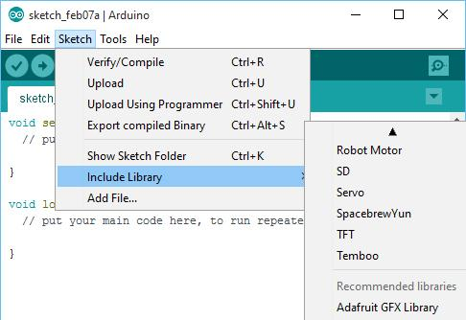

**Library for DHT 22 is installed**

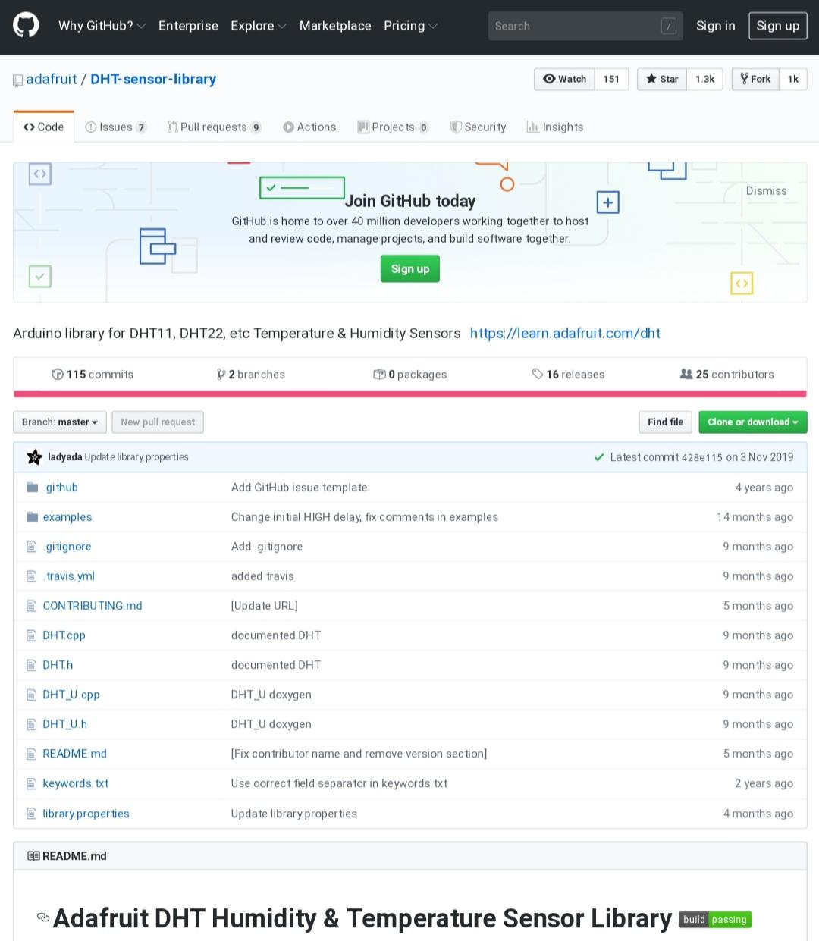

The library is downloaded as .zip file and included in the library of the Arduino.

Link:<https://github.com/adafruit/DHT-sensor-library>

Adafruit Unified sensor library is also downloaded for using dht 22 Library.

Link:<https://github.com/adafruit/Adafruit_Sensor>

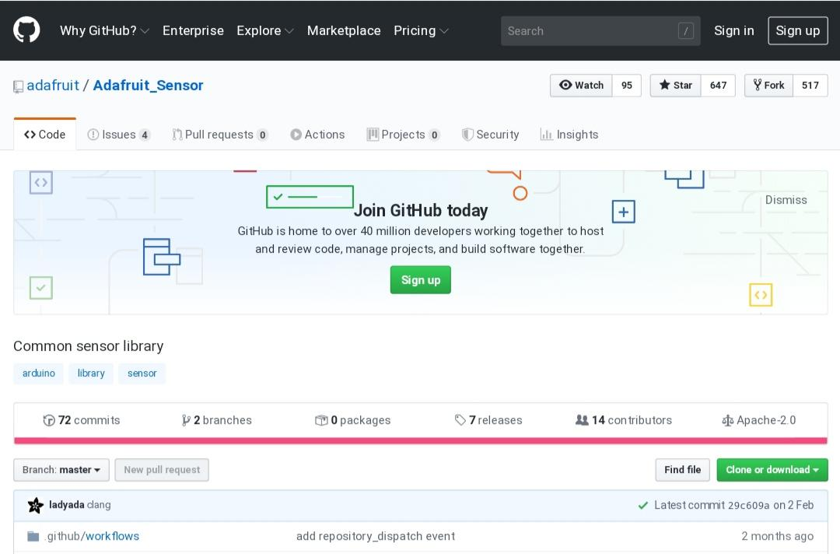

**Library for MPU6050 is installed**

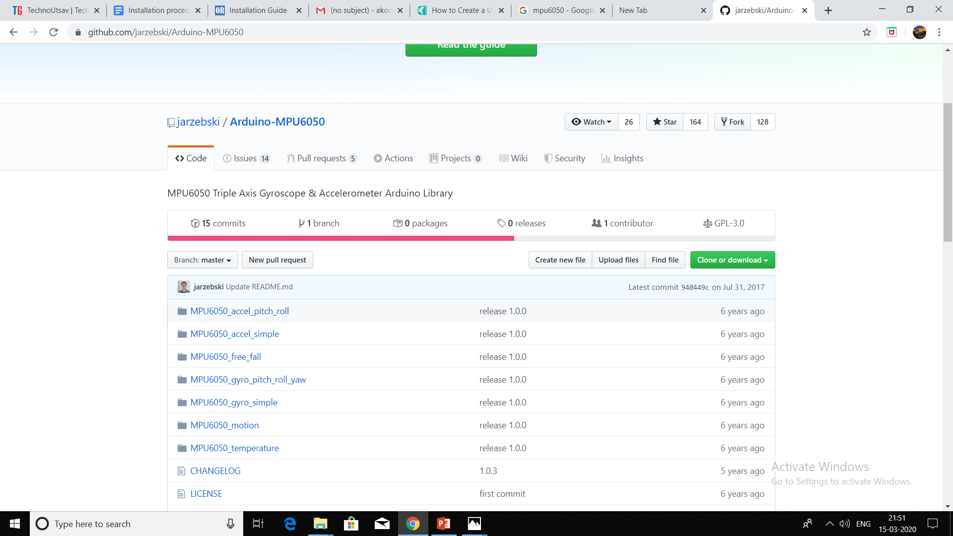

Download the zip file and extract it to the library folder of arduino to include the library.

**Tinygps+ (for NEO 6M module) Library**

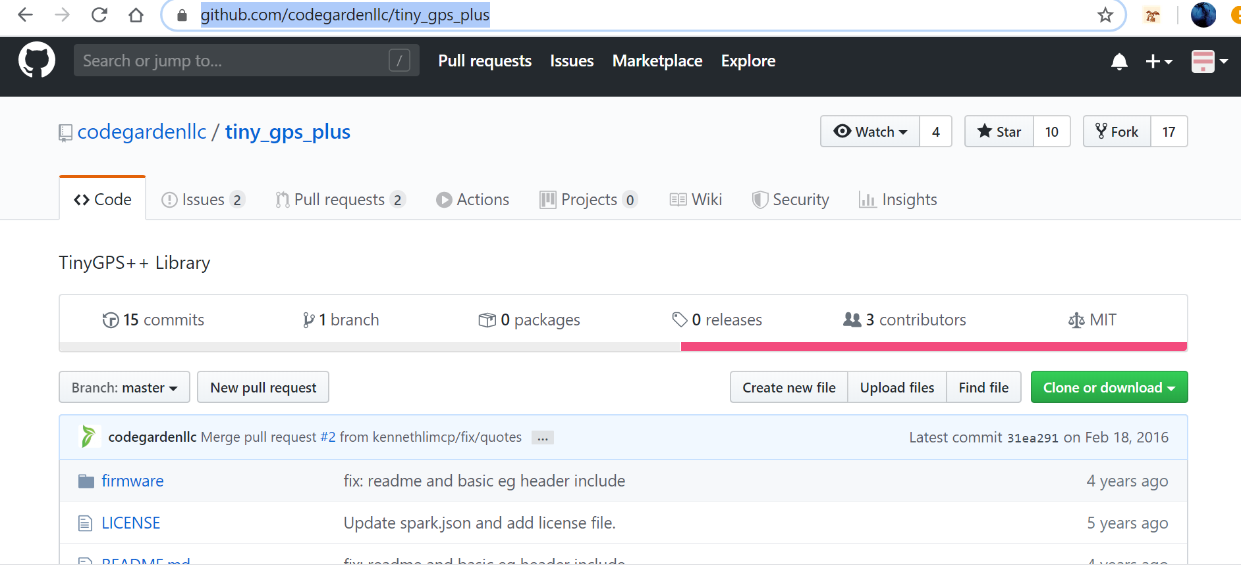

Install the Tinygps+ library from the link <https://github.com/codegardenllc/tiny_gps_plus> to include the library used to implement the gps tracking feature which would help determine the location of the worker

**Ubidots Library**

The values from NodeMCU is sent to Ubidots .This library is used to send the data to ubidots from NodeMCU. Link:<https://github.com/ubidots/ubidots-esp8266>

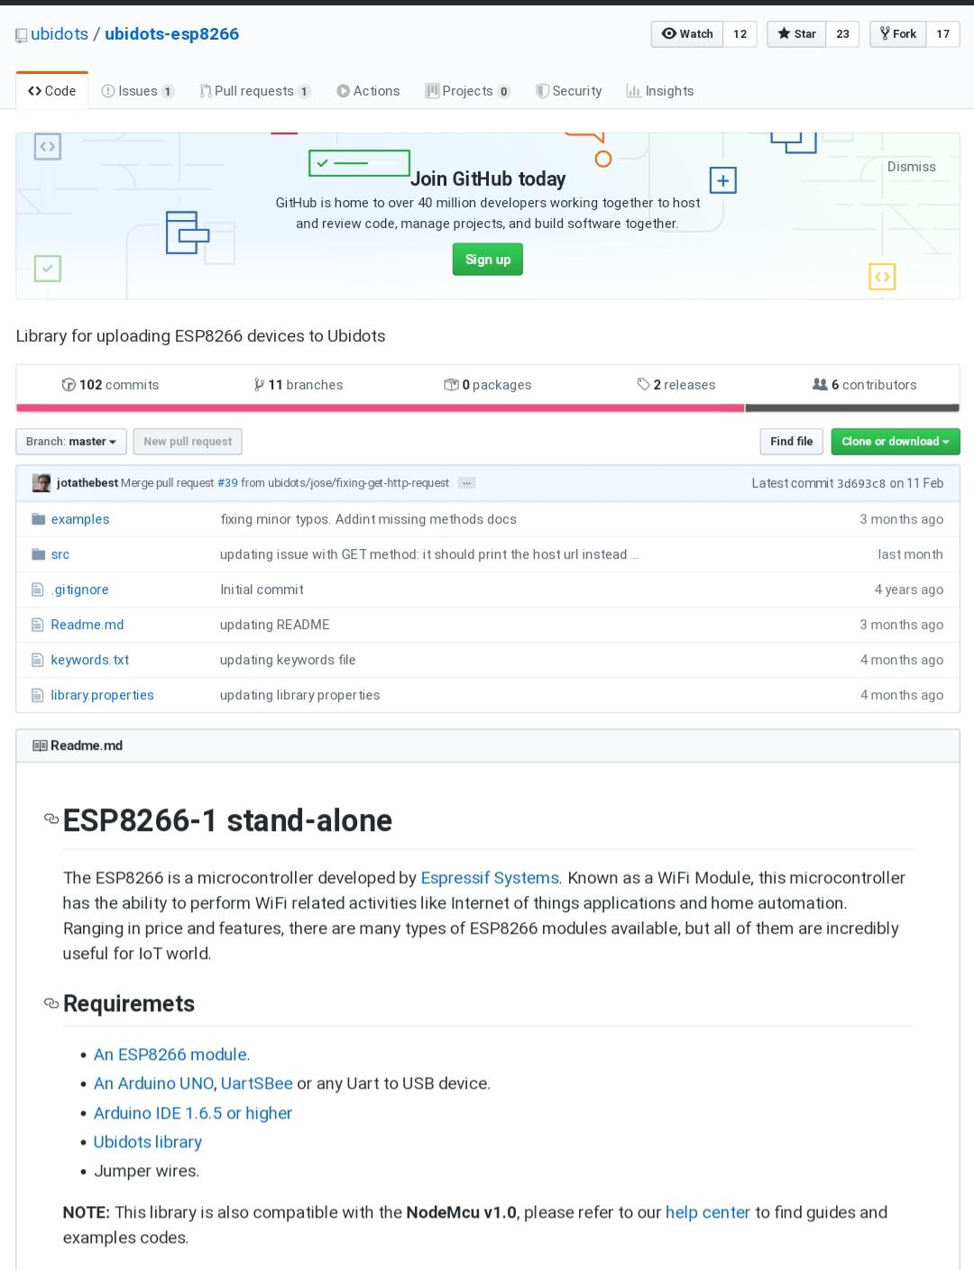

**ThingSpeak Library**

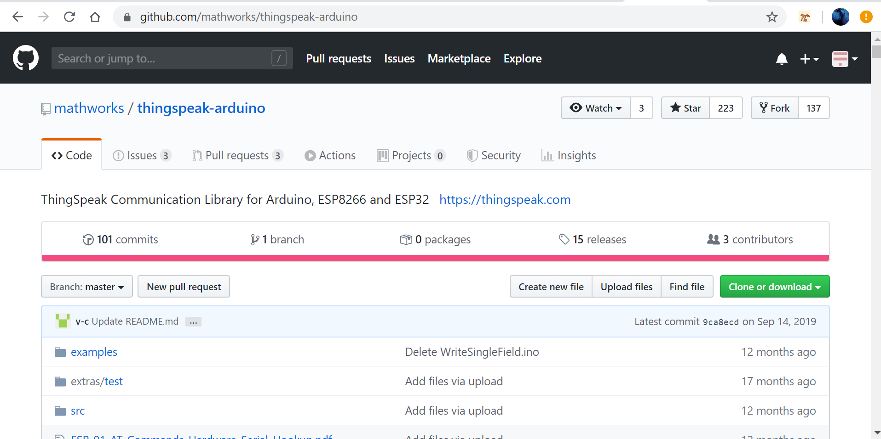

The library for ThingSpeak is installed from <https://github.com/mathworks/thingspeak-arduino>. Data from the sensors are sent over internet to ThingSpeak.

**Hardware**

The MQ9 sensors must be calibrated first.It also requires preheating time of 24-48 hours.

The calibration code is given below.

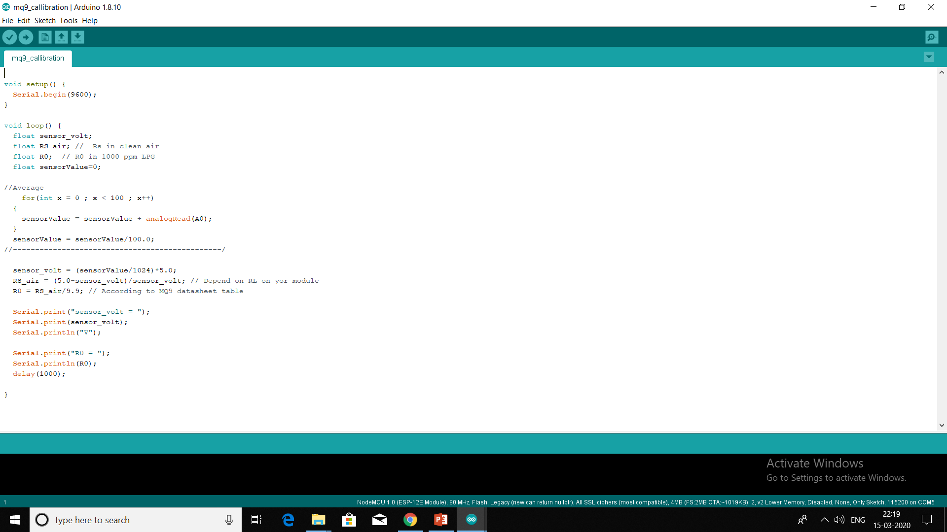

The other sensors are coded by including the required libraries

**What is Sevak and how to use it?**

It is comprised of 2 separate modules one for head gear and a watch.The module in the head gear consists of Temperature sensor(dht 22) ,gas sensor for detecting carbon monoxide,methane( MQ 09) and gas sensor for detecting hydrogen sulphide (MQ 135).If the gas levels in the working area of the drainage worker is in harmful levels a alert is sounded and a alert is sent to authorities.A GPS is also included to know the location of the worker.Ultra sonic sensor to detect obstacles in front of the workers.

The watch which is worn by the drainage worker under his hand gloves.It consists of heart rate sensor for detecting the fall in pulse in case his pulse falls due to the choking gas around him.The watch also has fall detection sensor for sensing the fall of the worker and an alert is sent.An emergency button for the worker.

**Heart Rate values**

An Ubidots account is created and the API token is included in the code.

The values are sent automatically to ubidots using a NodeMCU module, the library for ubidots and ESP8266 was included in the Arduino IDE.

In Ubidots a variable is created with name 'Heart Rate' and values are added in real -time.

A graph corresponding value of Heart rate in BPM is plotted.

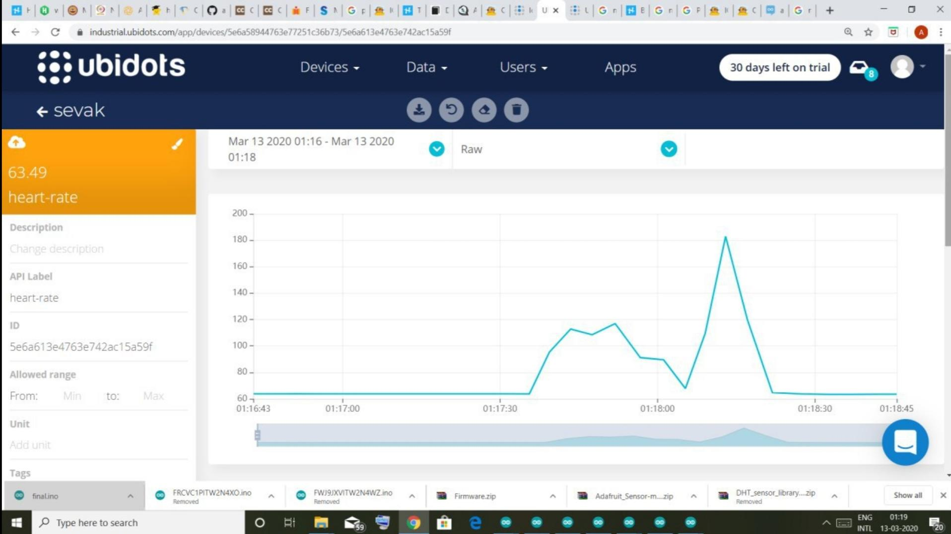

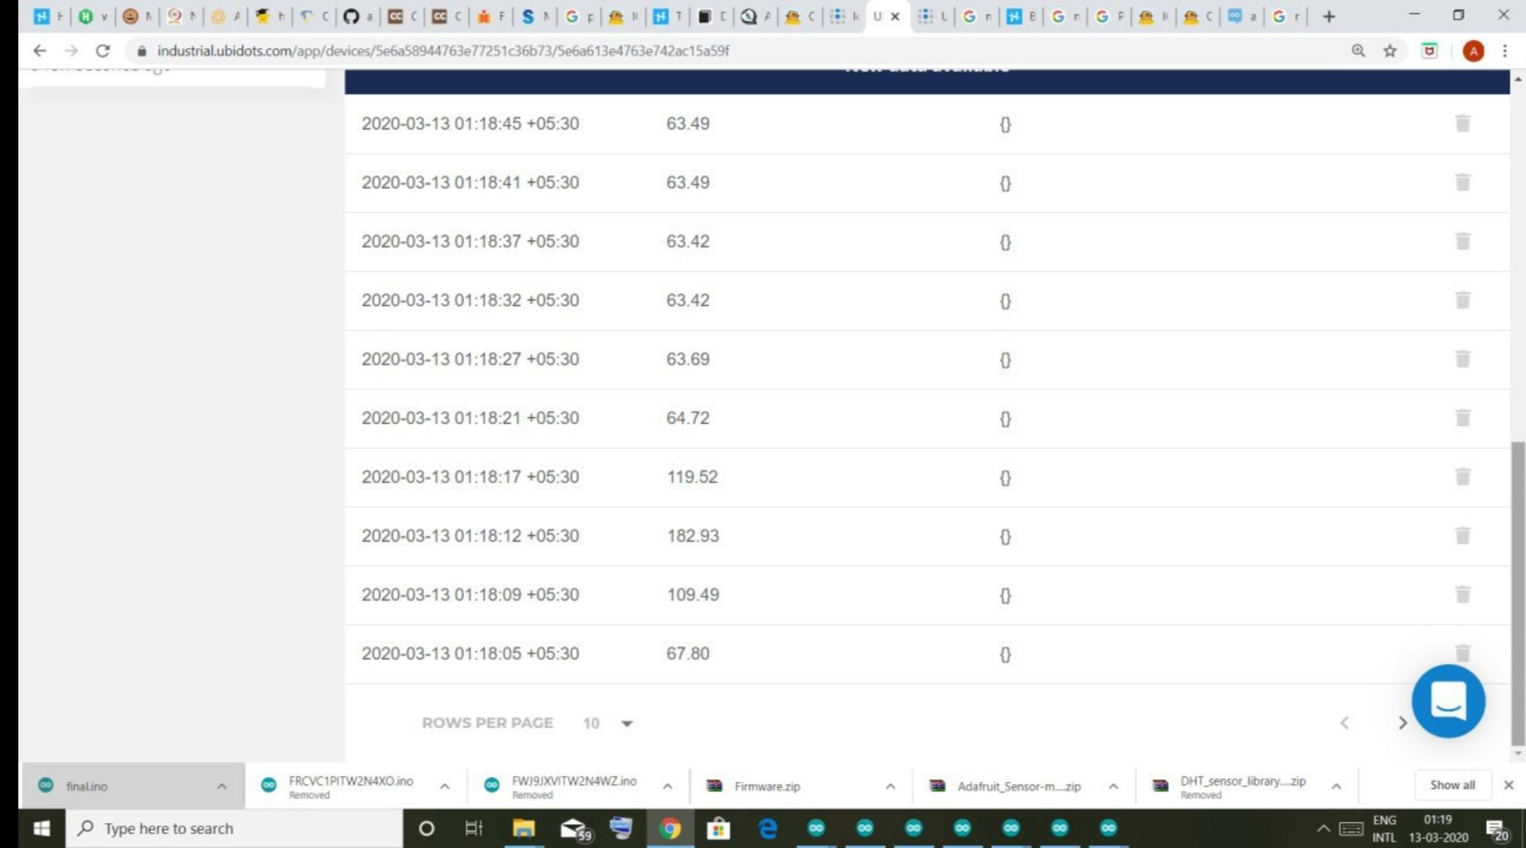

**Temperature of work area**

The values are sent to ubidots using a NodeMCU module, the library for ubidots and

ESP8266 was included in the Arduino IDE.

DHT 22 library was also included.

In Ubidots 'Temperature' Variable is created,values are updated real time in the ubidots

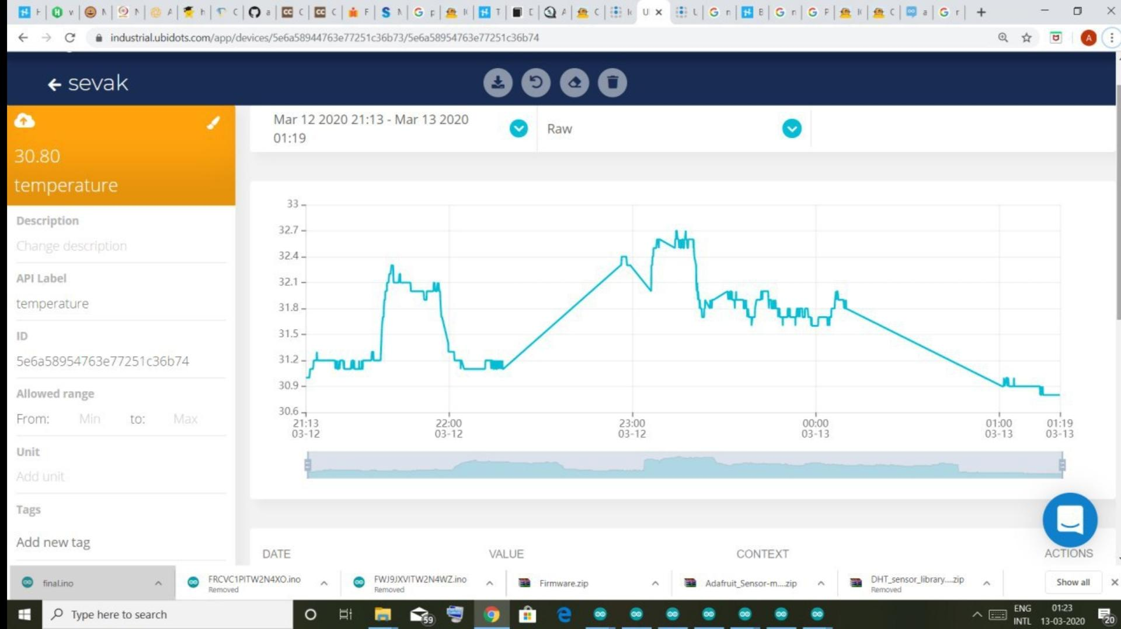

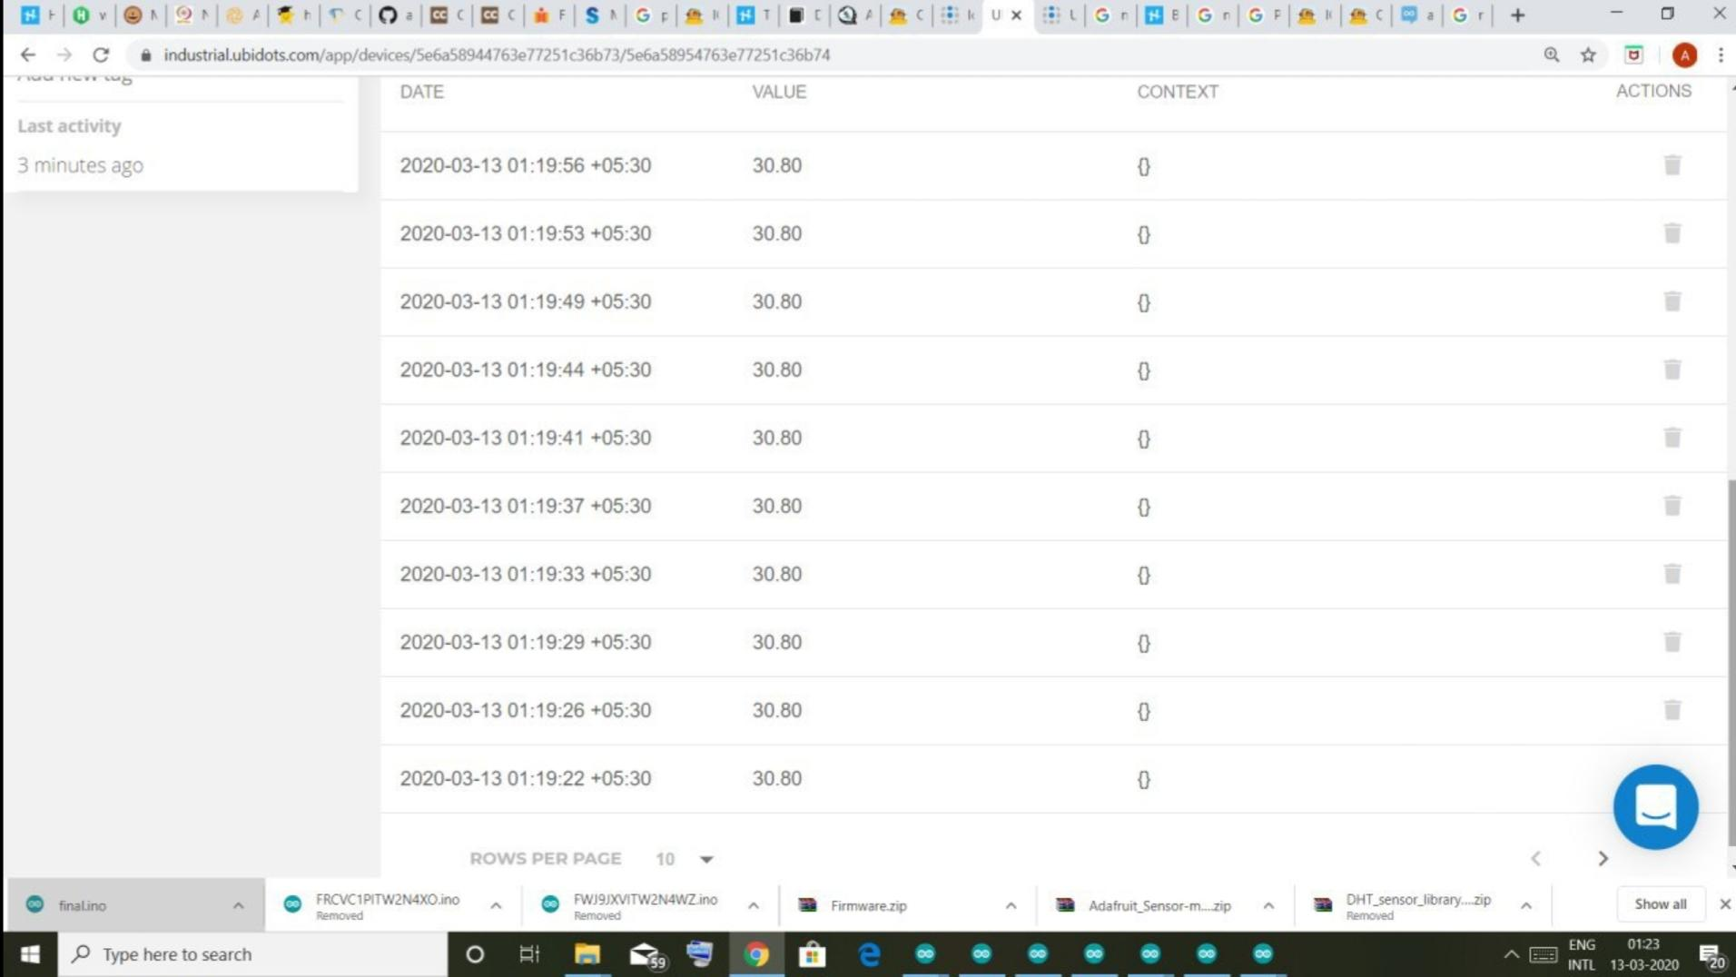

**Representing Heart Rate and Temperature on dashboard**

The variables 'Temperature' and 'Heart Rate' is included in the dashboard of Ubidots using widgets and the value is displayed and the last updated time is also displayed.

This can be converted into an App which can be used by the user or for monitoring the worker by the concerned authority.

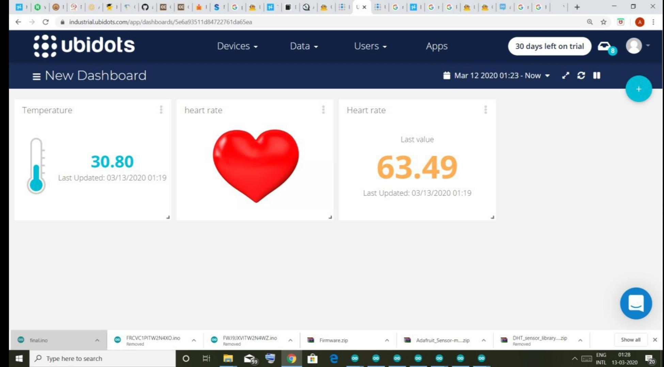

**Location of Worker**

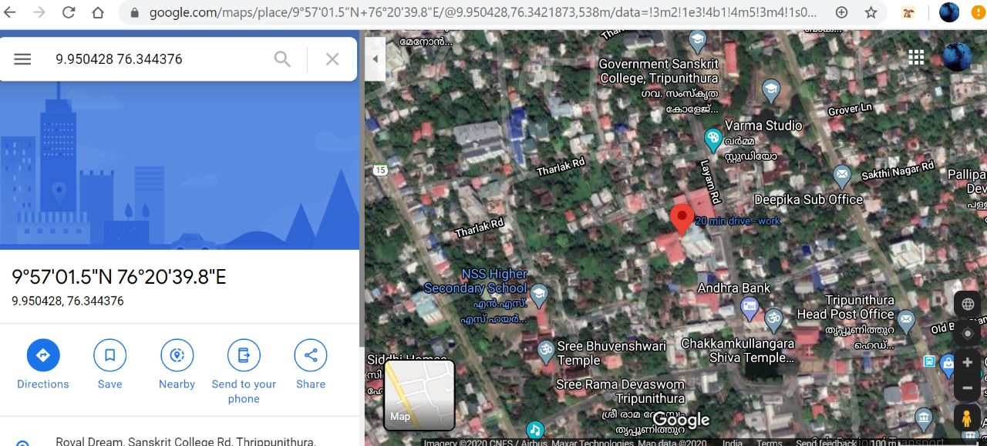

Location of the worker is obtained using a node mcu and a gps module. A simple local web server is created using NodeMCU and the location details are updated in that server webpage. Speciality of this feature is that we can check the location in Goolge Maps by clicking on the link provided in the web page. You can also open this webpage and check the location from anywhere by activate port forwarding in your modem/router.

**Gas level monitoring of Methane gas**

We will measure the quantity of gas in percentage and send it over the internet using the thingspeak server. With this system, the data can be monitored remotely staying at any part of the world. We just need gas sensor like MQ2 that is directly connected to Nodemcu ESP8266-12E Module.ThingSpeak is an open source Internet of Things (IoT) application and API to store and retrieve data from things using the HTTP protocol over the Internet or via a Local Area Network.This system can also be used to send alerts when the concentration of the gas crosses the threshold.

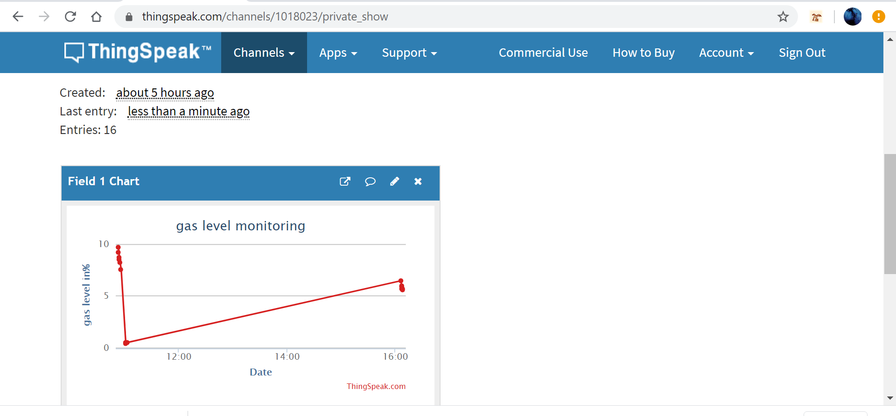

* Obstacle detection

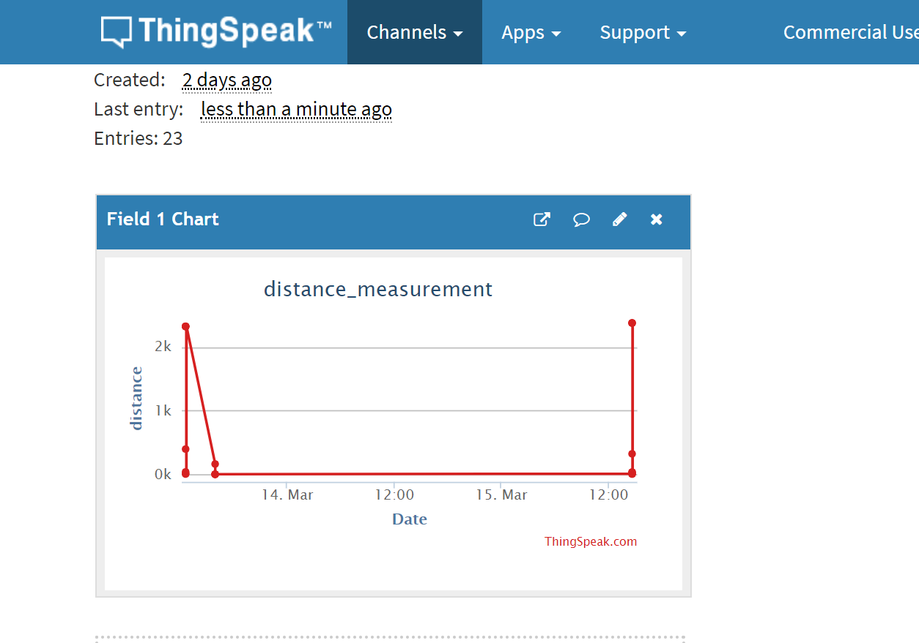

The system also has a feature of obstacle detection using ultrasonic sensor.

In the dark areas the distance between the worker and the obstacle is detected ,monitored and alerts are sent if the worker is too near the obstacle

Firstly, the Nodemcu will trigger the ultrasonic sensor and collects the data, and after calculating the distance, will convey this data to the serial monitor through the arduino ide. The serial data consists of distance data in cm with 3 to 5 decimal places. The program will send this data to your Thingspeak account via internet. The distance in cm is then plotted against the time as shown.

**Sending an Alert when BPM falls below 50**

We can create events or alerts that can be triggered for certain values in Ubidots.The alert can be message,call or email which can be set according to the user.

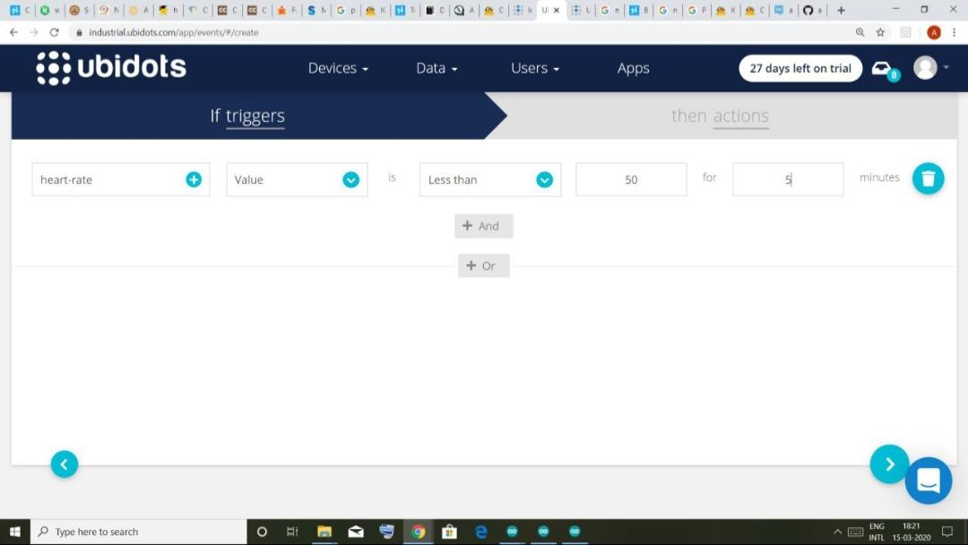

When the Beats per Minute falls below 50 an alert is send by mail and call

Mail:

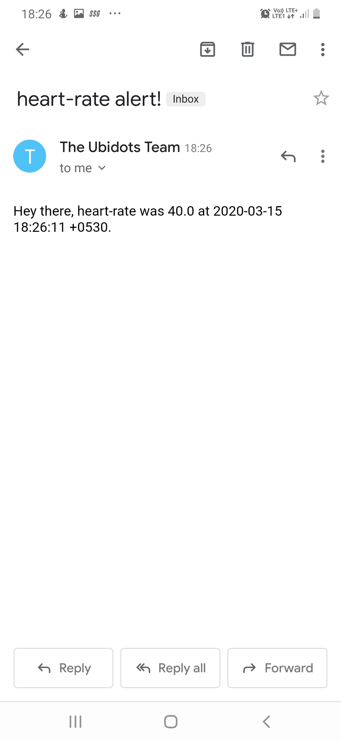

Call:

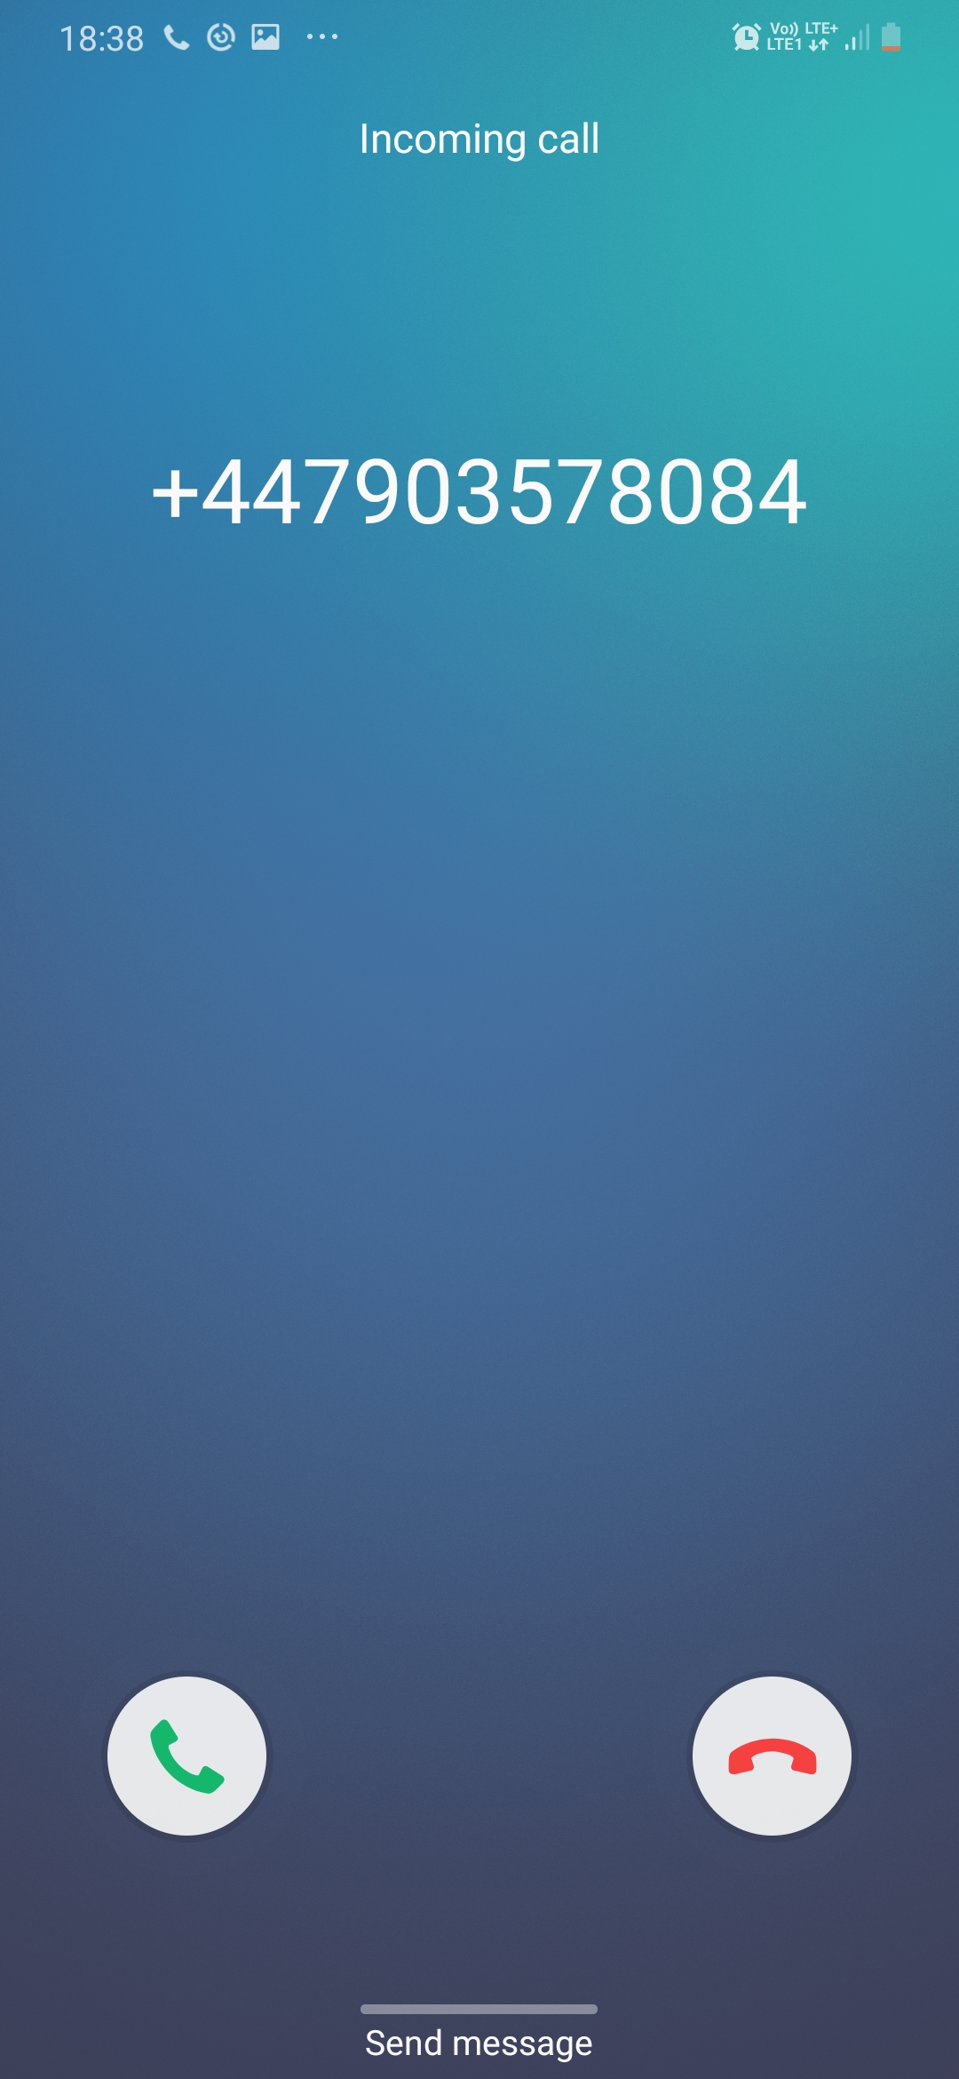

Similarly, Alerts are set for gas levels when it goes above a threshold level and the location of the drainage worker is sent only when he enters the drainage pipe to the contractor of the worker.

**Emergency Button**

The emergency button is used in situations where the worker is trapped or if any emergency situation arises due to which he need to contact the people outside.The button when pressed sends an alert immediately in the form sms or calls to the people outside.

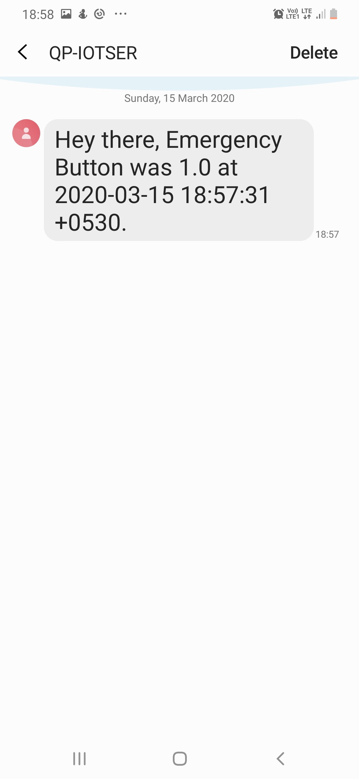

**Fall Detection**

Using Mpu-6050- a gyroscope accelerometer we are able to detect if the worker falls.When he falls an alert is automatically sent.

We will go with the threshold-based detection system and check whether a parameter is above a certain threshold value within a time interval. In a fall situation, there is a large change in acceleration within a split second and then after the fall, the person lies still for some time, showing no change in orientation.The parameter we use is the amplitude vector.

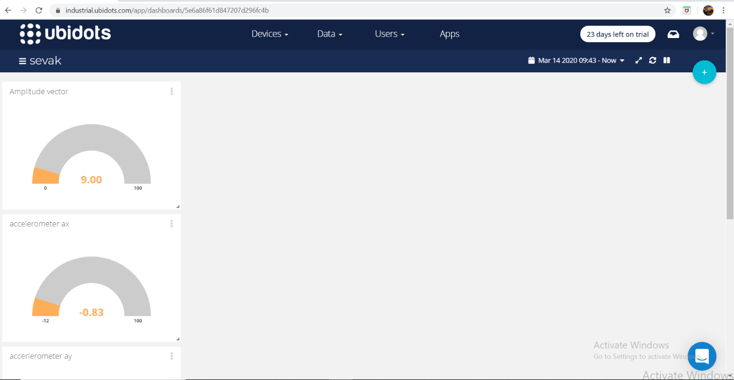

**The Carbon monoxide sensor**

CO is one of the most poisonous gases ever found. Its concentration is relatively higher in underground drains. This possesses a great health hazard to the people working inside.By using Mq9 that measures the CO concentration in ppm we can set a threshold value. If the concentration is greater than the threshold value an alert is sent immediately.

